DMF
Product Documentation
Pro-Video Database
Table of Contents
Introduction 3
General Notes About This Document 3
General Notes About The Database 3
Using The Database 4
Opening The Database 4
Closing The Database 5
The Main Menu 6
Borrower Management 7
Adding A Borrower To The Database 9
Viewing and Editing Individual Borrower Details 10
Viewing Borrower Details 12
Video Management 14
Adding A Video To The Database 15
Viewing and Editing Individual Video Details 18
Loan Management 20
Loaning A Video To A Customer 22
Viewing And Returning Loans 23
Supplier Management 26
Adding A Supplier To The Database 27
Viewing and Editing Individual Supplier Details 29
Viewing Supplier Details 31
Getting Help 33
Troubleshooting 33
Contacting DMF 34

Introduction
This documentation will make it easier to use your new database. It is recommended that you read this document in it's entirety before operating your database, and also check here before calling for support. Most of your problems can be answered by reading this document.

General Notes About This Document
<Coming-Soon>This documentation is logically sorted based on the hierarchical navigation system used in the database. The Table Of Contents points to various sections of the document based on the heading in use. There are three types of heading:
- The main headings, which indicate the main sections of the database
- The subheadings, which indicate the beginning of a section inside a major section
- The sub-subheadings, which indicate the beginning of a sub-section inside a major section.
You may also find notes inside their own boxes throughout the document, these point out useful bits of information without disrupting the logical flow of the document.

General Notes About The Database
The database which this documentation documents has been custom designed by DMF with ease of use in mind, it is therefore essential to know that certain standards have been employed, for example, many of the screens look similar and have the same buttons, this helps with the ease of use as it minimises the amount of learning that a person has to undertake to operate the database, it also makes it easier for a person to learn to use the database.
Some parts of the database are automated, for example the due date and cost of a loan are automatically calculated, saving is also automated an occurs every time you change, add or remove something from the database.
The database also runs on a hierarchical menu system, which logically seperates the sections of the database and makes it easy to find what you are looking for.

Using The Database

Opening The Database
To open the database, double-click on the Pro Video icon on your desktop.

When you open the database you will be prompted for your password.
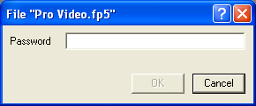
Enter your password and click on the OK button
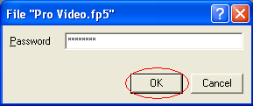
If you enter your password incorrectly you will be presented with a dialog bog informing you that you entered your password incorrectly. Click OK and try again.
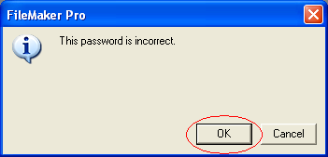
Once you have entered your password correctly you will be taken to the main menu.

Closing The Database
When you have finished with the database you will want to close it, this can be achieved in a number of ways.
- Choosing Exit from the File Menu
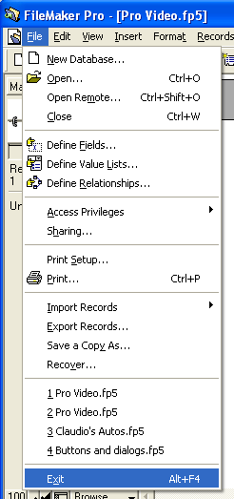
- Clicking on the X in the top-right corner of the database window. Please note that it is the top-most X that will close the database correctly.
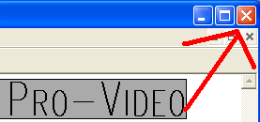
- Pressing Alt & F4 simultaneously on your keyboard.
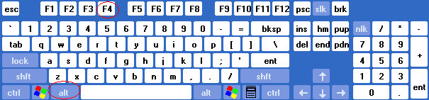
There is no need to save your changes as they are automatically saved whenever you make a change to the data in the database.

The Main Menu
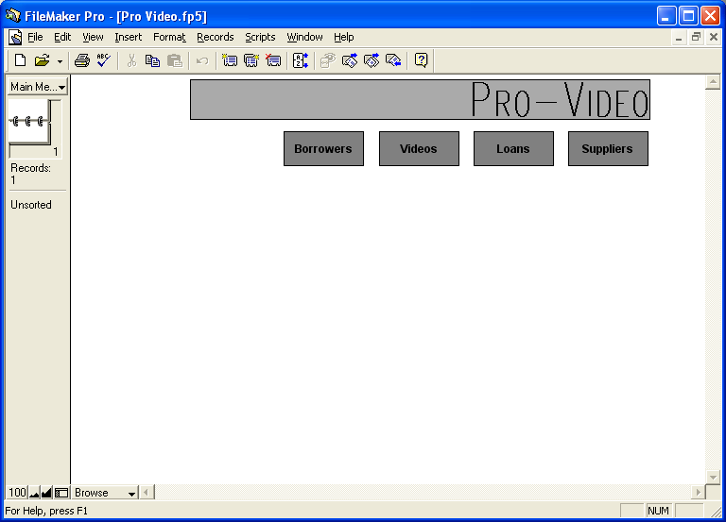
The Main Menu provides your window to the database, allowing you to choose what actions you wish to perform. The Main Menu has a logical selection of navigation buttons based on the various components of the system:
- Borrowers allows you to view, add and modify the details of the registered borrowers in the system.
- Videos allows you to view, add and modify the videos which are owned by Pro Video and potentially able to be borrowed by registered borrowers.
- Loans is your central navigation area for the management of loans. The loans area allows you to loan videos to registered customers, view current loans, see which loans are overdue and return loaned videos into the available library.
Note
It is easy to return to the Main Menu from within the sub-menus by clicking on the Main Menu button.
- Suppliers allows you to manage your list of suppliers, including viewing, modifying and adding details of suppliers.
Clicking on the button with the name of the area you wish to utilise will take you to that area.

Borrower Management
Managing borrowers is made easy by the logical hierarchical menu system used in the database. To enter the Borrower Management component of the database, click on the Borrowers button on the Main Menu.
Note
Only click once, a double click is not needed and may result in you accidentally clicking on a button on the next menu.

After doing that you will be presented with the Borrowers Menu
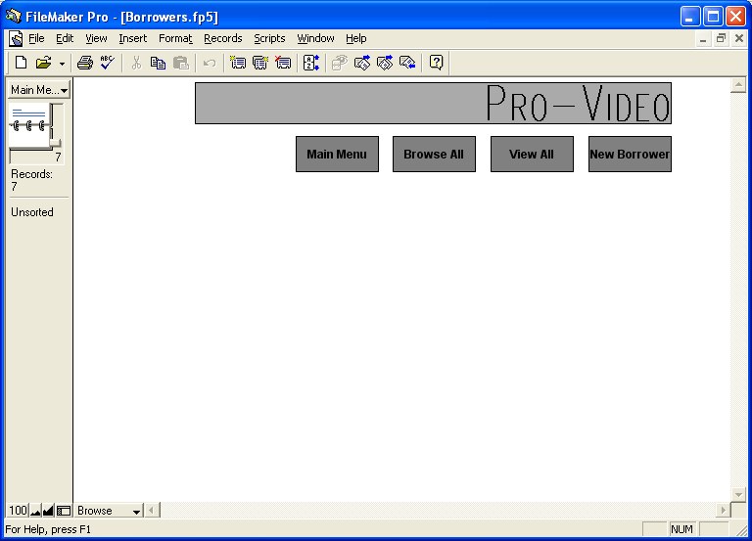
The Borrowers Menu enables you to manage your borrowers and contains a number of navigation buttons to make this task easier.
- Main Menu takes you back to the Main menu of the database so that you may enter other sections of the database.
- Browse All shows you a borrower by borrower detailed view of each borrower, which also enables you to modify the details of each borrower.
- View All allows you to view an overview of the borrowers and their current blacklist status
- New Borrower allows you to add a new customer to the database as a borrower, so that they can borrow videos.
You can return to the Main Menu by clicking on the Main Menu button.
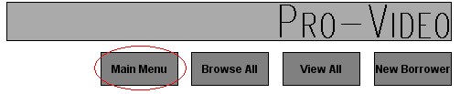

Adding A Borrower To The Database
From the Borrowers Menu, click on New Borrower
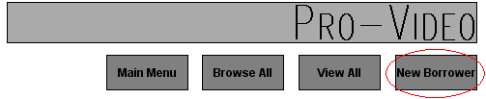
You will then be presented with the New Borrower screen.
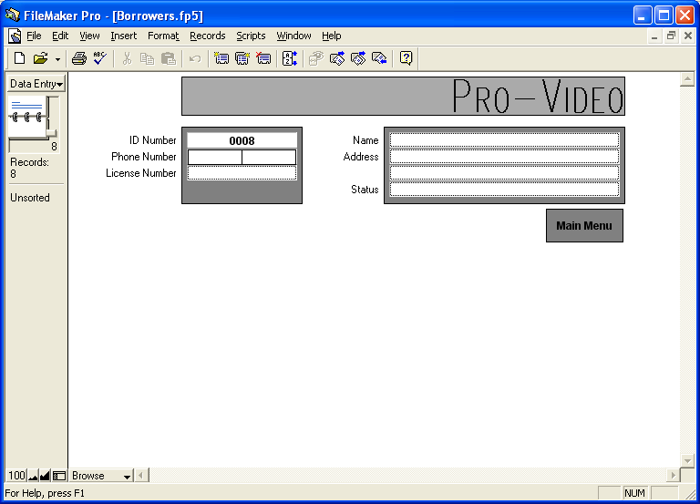On this screen you can enter the details of the new borrower, these details are as follows:
- ID Number: Automatically entered by the system
- Phone Number: The phone number of the borrower
- License Number: The Driver's License (or other appropriate identification as decided by store management) number.
- Name: The name of the borrower
- Address: The address of the borrower (This may be residential or postal as decided by store management)
- Status: Whether or not the borrower is allowed to borrow videos, the two possibilities will appear in a pop up menu and they are
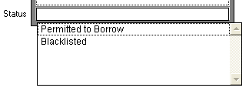
  - Permitted to Borrow: This allows the borrower to borrow videos
  - Blacklisted: This bans the borrower from borrowing videos
Once you have finished adding the borrower to the database, click the Main Menu button to be taken back to the Borrowers Menu.
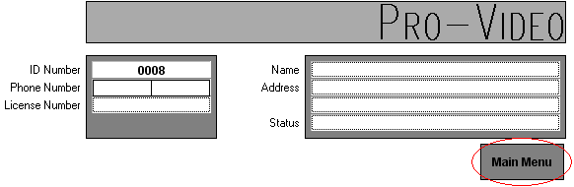

Viewing and Editing Individual Borrower Details
You can view borrower details on either a borrower by borrower basis, or an overview of all borrowers. When you view the details of an individual borrower you are able to edit their details, when you view an overview of all the borrowers you are only able to view their details. To view or edit the details for just one borrower at a time, click the Browse All button on the Borrowers Menu.
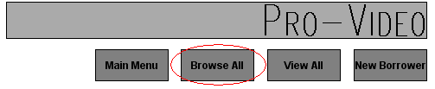
This will present you with a screen similar to the New Borrower screen.
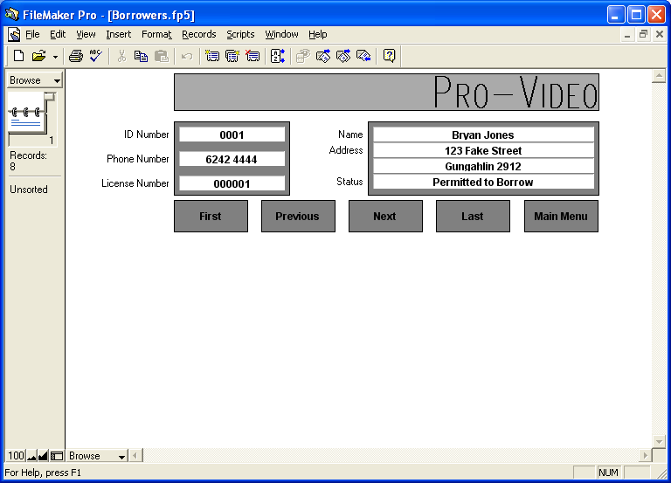
On this screen you can see all of the borrower's details, as well as modify them.
There are a series of buttons on the screen which all do various things:
- First: This button takes you to the first borrower in ID Number order.
- Previous: Takes you to the previous borrower in ID Number order.
- Next: Takes you to the next borrower in ID Number order.
- Last: Takes you to the last borrower in ID number order.
- Main Menu: Takes you back to the Borrowers Menu
Once you have finished with browsing the borrower details, you can return to the Borrowers Menu by clicking on the Main Menu button.
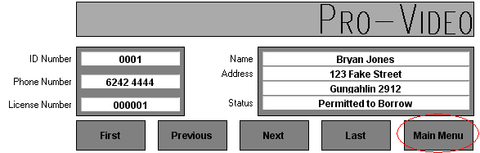

Viewing Borrower Details
Note
You can only edit borrower details from the Browse view, the overview is for viewing purposes only.
You can view all the borrowers at a glance by clicking on View All on the Borrowers Menu.
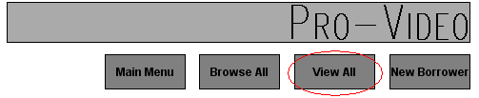
This will bring up an overview of the borrowers.
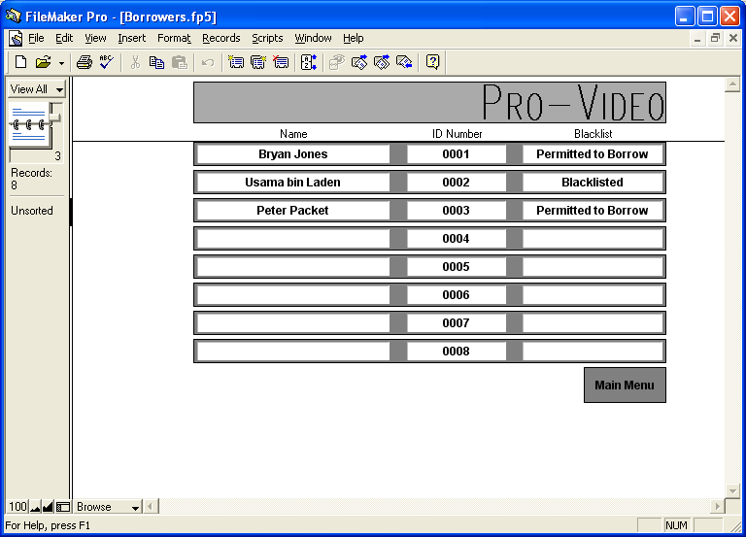
In this view you are unable to modify borrower details. Once you are finished with this view, click Main Menu to be returned to the Borrowers Menu.
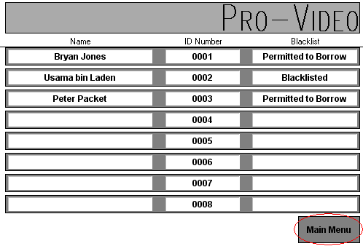

Video Management
Managing videos is done in a similar way as managing borrowers. To enter the video management section of the database, click the Videos button on the Main Menu.

This will bring up the Videos Menu
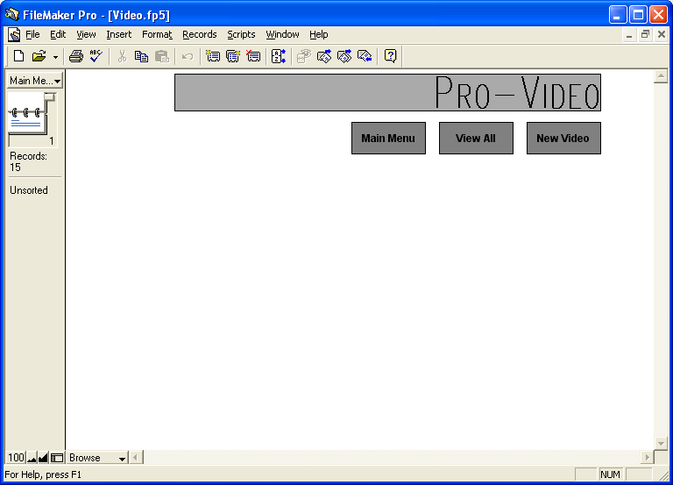
The Videos Menu enables you to manage your borrowers and contains a number of navigation buttons to make this task easier.
Note
The Videos Menu has three buttons by design, which makes it slightly different to other menus.
- Main Menu takes you back to the Main menu of the database so that you may enter other sections of the database.
- View All shows you a video by video detailed view of each video, which also enables you to modify the details of each video.
- New Video allows you to add a new video to the database.
You can return to the Main Menu by clicking on the Main Menu button.


Adding A Video To The Database
From the Videos Menu, click on New Video

You will then be presented with the New Video screen.
Note
Make sure the supplier is in the database before adding a video from that particular supplier.
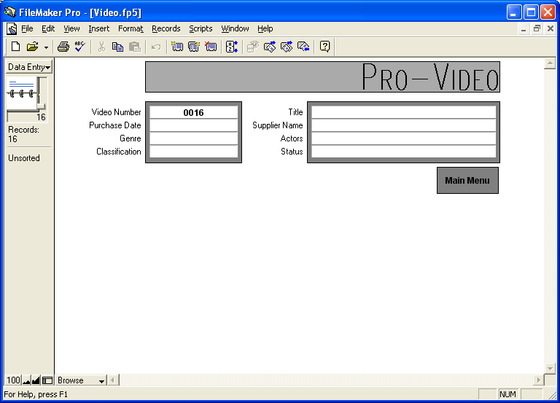On this screen you can enter the details of the new video, these details are as follows:
- ID Number: Automatically entered by the system
- Purchase Date: The date on which the video was purchased
- Genre: The genre of the video, this is entered in a popup menu. The possible genres are:
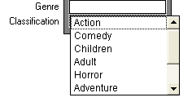
  - Action
  - Adult
  - Adventure
  - Children
  - Comedy
  - Documentary
  - Horror
  - Sci-Fi
- Classification: The classification listed on the video, the possibilities are:
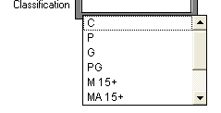
  - C: Children
  - P: Preschool
  - G: For general exhibition
  - P: Parental guidance recommended for persons under 15 years of age
  - M 15+: Recommended for person 15 years and over
  - MA 15+: Not suitable for persons under 15 years of age. Persons under 15 years of age must be accompanied by a parent or an adult
  - R: Restricted to persons 18 years and over
- Title: The title of the video (Usually on the front cover in large writing, and on the spine in smaller writing, and often on the back of the video as well as the label on the video.)
- Supplier Name: The supplier of the video, this is entered in a popup menu.
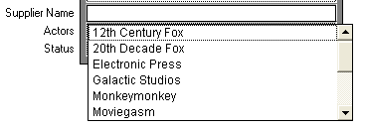
- Actors: The main actors in the video
- Status: The status of the video, this feature enables you to add a video to the database before it has arrived in the store if you desire. The possible statuses are:
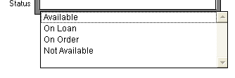
  - Available
  - On Loan
  - On Order
  - Not Available
Once you have finished adding the video to the database, click the Main Menu button to be taken back to the Videos Menu.
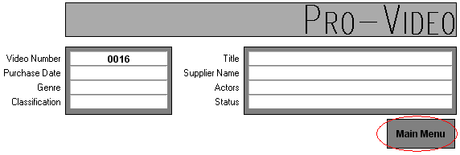

Viewing and Editing Individual Video Details
You can view video details on a video by video basis. When you view the details of an individual video you are able to edit it's details. To view or edit the details of a video, click the View All button on the Video Menu.


This will present you with a screen similar to the New Video screen.
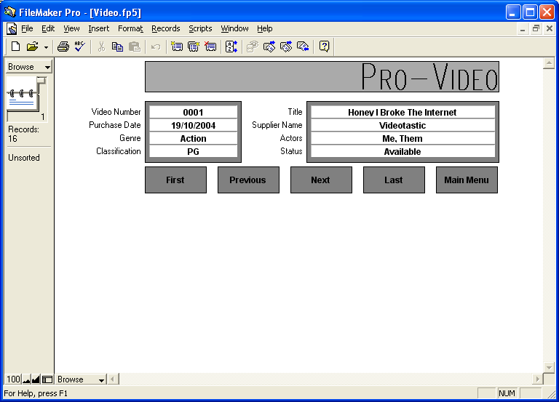
On this screen you can see all of the video's details, as well as modify them.
There are a series of buttons on the screen which all do various things:
- First: This button takes you to the first video in ID Number order.
- Previous: Takes you to the previous video in ID Number order.
Note
These buttons are standard throughout the browse screens in the database. This standard is designed for ease of use.
- Next: Takes you to the next video in ID Number order.
- Last: Takes you to the last video in ID number order.
- Main Menu: Takes you back to the Videos Menu
Once you have finished with browsing the borrower details, you can return to the Videos Menu by clicking on the Main Menu button.
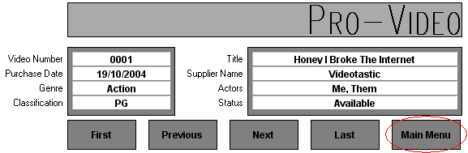

Loan Management
Managing loans is done in a similar way as managing videos, although it is important to note that there are more differences between the management of loans and videos than there are between managing videos and borrowers. To enter the loan management section of the database, click the Loans button on the Main Menu.
Note
Loan management has it's own differences and it is very important to understand them, please read this section carefully.
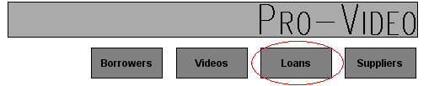
This will bring up the Loans Menu
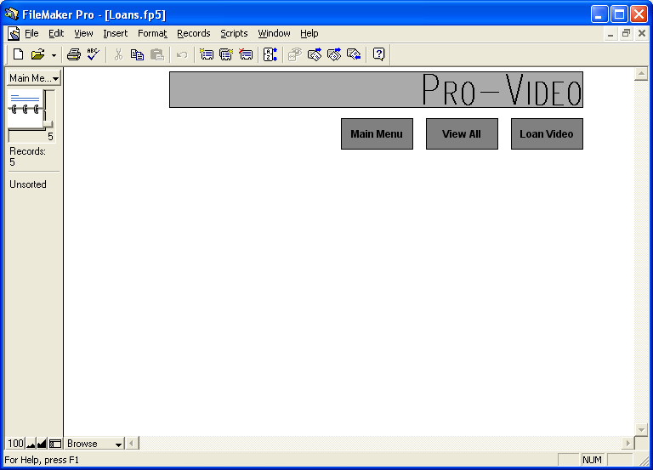
The Loans Menu enables you to manage your loans and contains a number of navigation buttons to make this task easier.
- Main Menu takes you back to the Main menu of the database so that you may enter other sections of the database.
- View All allows you to view an overview of the current loans and their overdue status. You can also return videos from this section.
- Loan Video allows you to loan a video out to a customer.
You can return to the Main Menu by clicking on the Main Menu button.


Loaning A Video To A Customer
You can loan a video to a customer by clicking on the Loan Video button on the Loans Menu

This brings up the Loan Video screen.
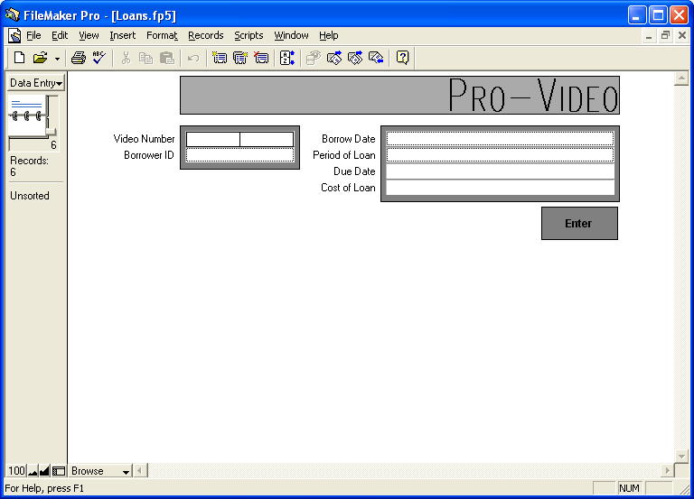
On this screen you can enter the details of a new loan, the details are as follows:
- Video Number: This is the ID number of the video being borrowed.
- Borrower ID: This is the ID number of the borrower.
- Borrow Date: This is the date on which the video was borrowed, usually the same day as the day you are entering the loan on.
- Period Of Loan: This is how long the loan will go for, the options are:
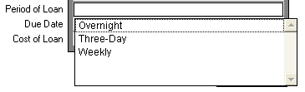
  - Overnight
  - Three days
  - Seven days
- Due Date: This is the date on which the video is due back in the store, this is automatically calculated
Note
The due date and cost of loan are calculated automatically, do not attempt to enter the information manually.
- Cost Of Loan: This is the amount which the borrower has to pay to borrow the video, this is automatically calculated.

Viewing And Returning Loans
You can view and return loans by clicking the View All button on the Loans Menu
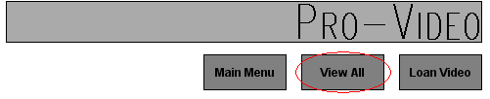
This brings up the Loan Overview screen
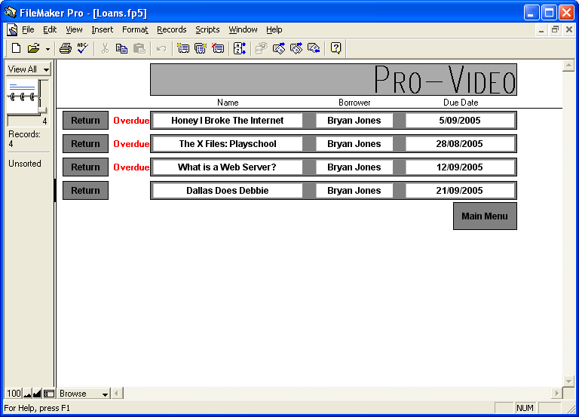
The Loans Overview screen shows all of the current loans with the following information:
- Name of video
- Name of borrower
- Due Date
- Overdue Status: If a video is overdue, the word “overdue” appears in red writing to the left of the loan entry.
Note
Depending on your company policy, it may be important to note the due date of overview videos before returning them to calculate any overdue fees.
To return a loan, click the Return button next to it
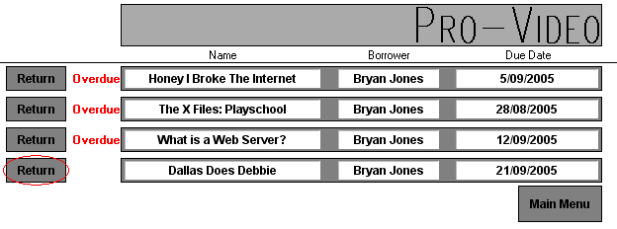
You will then be prompted for verification:
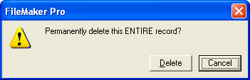
To return the video, click the Delete button. This removes the loan from the database.
Note
As returning a video deletes the loan from the database, make sure you take not of any important details before returning it.
To not return the video, click the Cancel button.
One you have finished with the Loans Overview screen, click the Main Menu button to return to the Loans Menu.
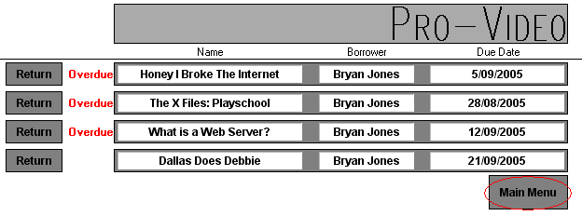

Supplier Management
Managing suppliers is made easy by the logical hierarchical menu system used in the database. To enter the Supplier Management component of the database, click on the Suppliers button on the Main Menu.
Note
Suppliers should be added before you add any videos from that supplier to the system. Adding the supplier makes it appear in the add video screen.

After doing that you will be presented with the Suppliers Menu
The Suppliers Menu enables you to manage your suppliers and contains a number of navigation buttons to make this task easier.
- Main Menu takes you back to the Main menu of the database so that you may enter other sections of the database.
- Browse All shows you a supplier by supplier detailed view of each supplier, which also enables you to modify the details of each supplier.
Note
Suppliers should not be removed from the database before videos from them are removed as this would invalidate some video entries.
- View All allows you to view an overview of the suppliers.
- New Supplier allows you to add a new supplier to the database .
You can return to the Main Menu by clicking on the Main Menu button.
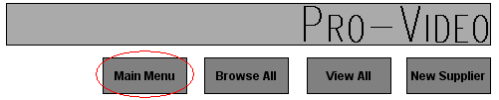

Adding A Supplier To The Database
From the Suppliers Menu, click on New Supplier

You will then be presented with the New Supplier screen.
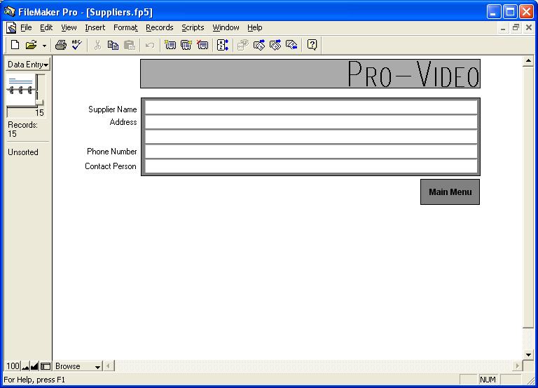
On this screen you can enter the details of the new supplier, these details are as follows:
- Supplier Name: The business name of the new supplier
Note
Do not mix up the Supplier Name and the Contact Person. The Supplier Name's appear in the new video screen.
- Address: The address of the supplier
- Phone Number: The phone number of the supplier
- Contact Person: The name of the contact person at the supplier
Once you have finished adding the supplier to the database, click the Main Menu button to be taken back to the Suppliers Menu.
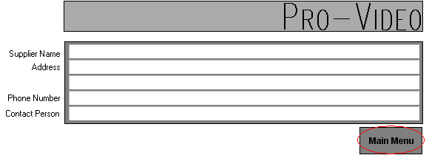

Viewing and Editing Individual Supplier Details
You can view supplier details on either a supplier by supplier basis, or an overview of all suppliers. When you view the details of an individual supplier you are able to edit their details, when you view an overview of all the suppliers you are only able to view their details. To view or edit the details for just one borrower at a time, click the Browse All button on the Suppliers Menu.
Note
This is similar to the viewing and editing borrowers system in that you have browse and overview screens.

This will present you with the Browse Suppliers screen.
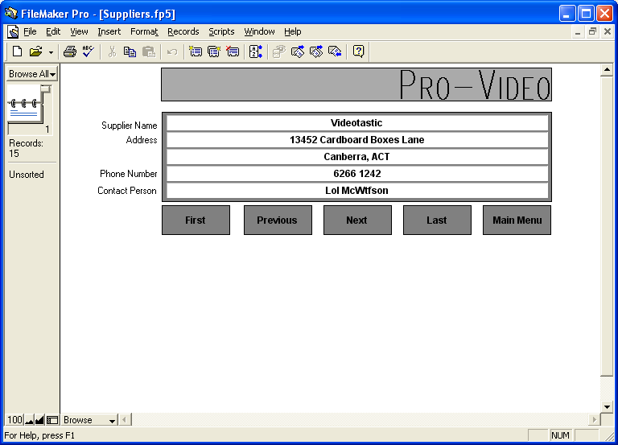
On this screen you can see all of the supplier's details, as well as modify them.
There are a series of buttons on the screen which all do various things:
- First: This button takes you to the first supplier in ID Number order.
- Previous: Takes you to the previous supplier in ID Number order.
- Next: Takes you to the next supplier in ID Number order.
- Last: Takes you to the last supplier in ID number order.
- Main Menu: Takes you back to the Suppliers Menu
Once you have finished with browsing the supplier details, you can return to the Suppliers Menu by clicking on the Main Menu button.
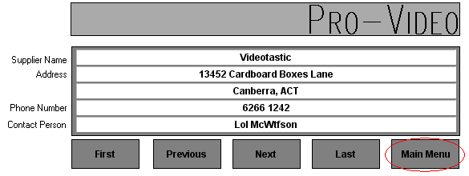

Viewing Supplier Details
You can view all the suppliers at a glance by clicking on View All on the Suppliers Menu.
Note
You can only edit the supplier details from the browse screen.
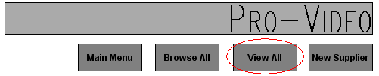
This will bring up an overview of the suppliers.
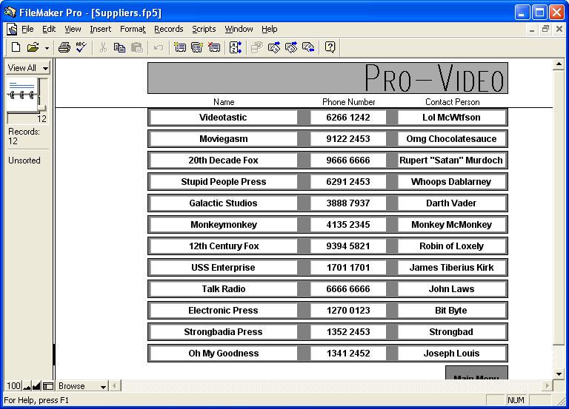
In this view you are unable to modify supplier details. Once you are finished with this view, click Main Menu to be returned to the Suppliers Menu.
Note
The overview screen only shows an overview of the details of each supplier, for more details see the browse screen.
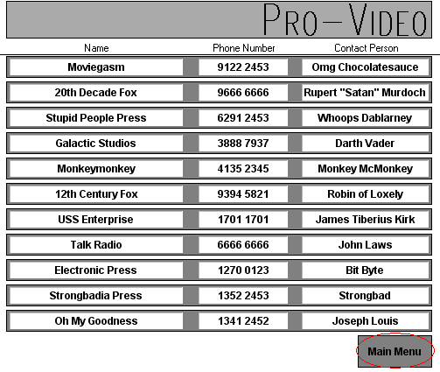

Getting Help
On occasion you may need help with the database, before calling DMF for assistance you should look follow this procedure:
- Read the manual, have a look at the relevant section of the manual to see if it addresses your problem. If that doesn't fix the problem;
- Read the troubleshooting section below which might answer your question. If that also doesn't fix your problem;
- Ask another member of staff (if possible) if they know the answer, in most cases they will. If that still doesn't fix the problem;
- Contact DMF, see the Contact DMF section below

Troubleshooting
The following section describes common problems and solutions
Problem | Solution
I forgot the password | Ask another member of staff or check with your manager.
I loaned the video to the wrong person or loaned the wrong video. | Return the loan and try again.
FileMaker Pro crashed. | Try opening the database again, if that doesn't work then try restarting the computer, if the problem persists contact DMF.
FileMaker is giving me strange errors. | Make sure you have read/write access to the database (ie. Don't run it from a CD-ROM).  If the problem prevents you from running the database, follow any instructions the error may give you, if that fails contact DMF.
I can't see the Pro Video database. | Can you see the desktop?  Is the computer turned on?  If the icon is missing, try and find the folder in which the database is stored and double click on Pro Video.  If all else fails, contact DMF.
How do I work out which videos are overdue? | Have a look at the Loans Overview screen by clicking on Loans from the Main Menu and then clicking on the View All button.

Contacting DMF
If all else fails, contact DMF on (02) 6248 6935, Fax DMF on (02) 6248 6936 or email DMF support@dmf.com.au

